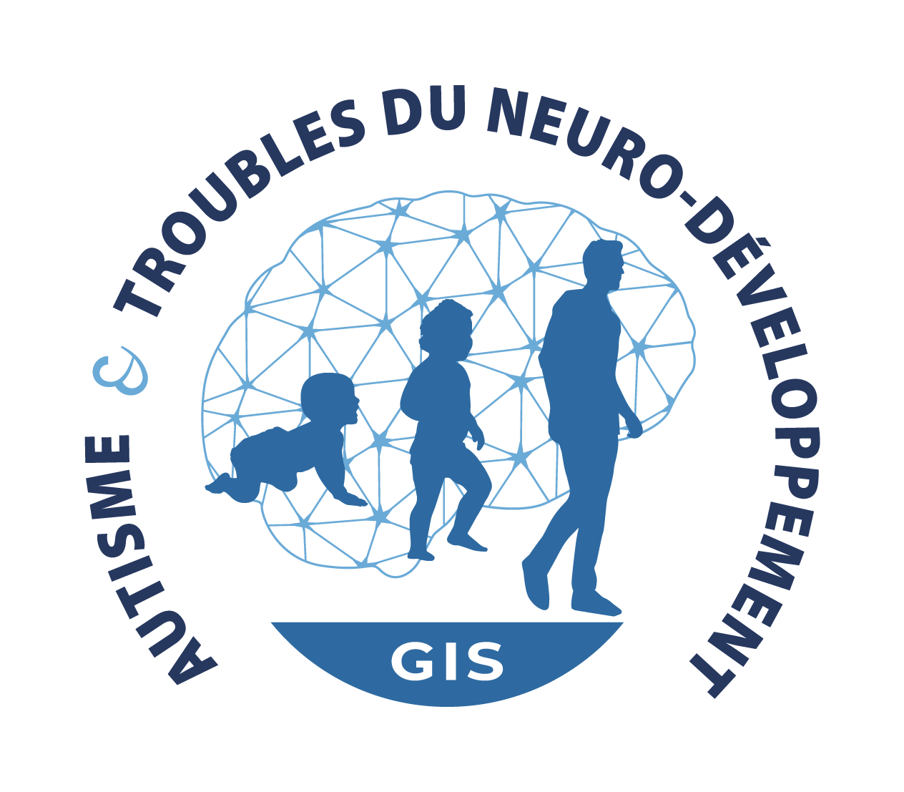

Invitation to participate in the Autism and Neuro-Developmental Disorders GIS as international associated partners:

Supported by the French National Strategy for Autism and Neuro-Developmental Disorders (NDD), Autism and NDD GIS (Scientific Interest Group) aims to develop an international research network. GIS’ missions are to:
- carry out an inventory of the teams involved in the study NDD, expertise, methodologies, tools and resources of the research community
- develop and coordinate a multidisciplinary research network extending to all NDDs, all disciplinary fields combined
- make link between research and non-profit organization, by setting up participatory research systems
- promote exchanges with European and international research actors
- increase the visibility of the scientific community actions

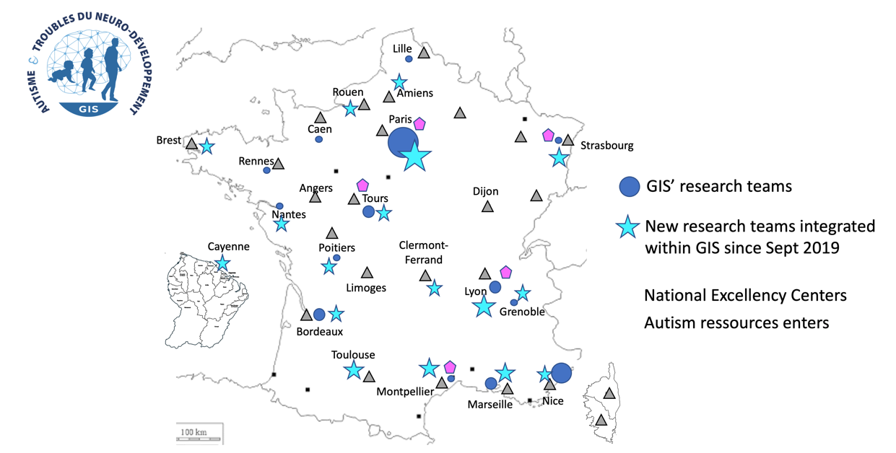
Map of GIS member teams, national excellency centers, autism resources centers - update October 13, 2021

GIS currently federates within its scientific research network more than 100 French research teams (see list in annex 1). These teams were initially grouped into 4 thematic axes based on developmental age windows covering NDD pathophysiology from prenatal to adulthood:
- Perinatal period, prematurity: early gene-environment interactions
- Developmental trajectories: neurofunctional explorations and bioclinical correlations
- Evolutionary trajectory from adolescence to adulthood
- Autism spectrum disorder in adulthood

The new expertise integrated in the GIS led to the creation of two new thematic axes based on:
- Neurodevelopment and learning. This thematic axis aims to federate researchers working on phenomena underlying normal development and learning. This is essential to enable GIS to address a wider range of NDDs (e.g., ADHD, DYS disorders, intellectual disabilities) allowing the inclusion of complementary scientific and clinical disciplines.
- Pre-clinical models. This thematic axis brings together basic and computational neuroscience researchers who aim to advance clinical translational impact through links with clinical researchers. This point is crucial in order to set up an efficient research community, equipped with tools at the cutting edge of clinical translational research about NDDs.

GIS has been promoting networking within its research community by providing support for “transversal actions”. Transversal actions are workgroups organized around common research themes / methodologies / resources. This support permitted the emergence of 14 sub-networks within the GIS (see list in annex 2): These collaborative initiatives spread over the entire spectrum of research:
- ranging from genes, identification of biomarkers and pathophysiological risk factors,
- to collaborations that will allow direct benefits for persons with NDD and families, promoting the development of innovative treatment and care strategies.

After bringing synergy within the French research community and the establishment of links with non-profit organizations, 2022 must be a year to ramp-up of current GIS actions. This ambition implies bringing GIS scientific actions to an international level.

Wishing to enrich its areas of expertise, GIS invites international scientific research teams working on autism and / or Neuro-Developmental Disorders, all disciplinary fields combined, willing to join its network as “international associated partners”.

The international associated partners will be eligible to participate in the collaborative scientific actions coordinated by the French teams, members of the GIS’ research network.

This invitation is addressed to teams meeting the cumulative criteria set out below:

- Labeled research team (certified by a national partner institution), whose research project applies to Autism and / or Neuro-Developmental Disorders.
- Research team that can attest to scientific collaborations with French research teams that are members of GIS.
- Team whose leader can attest to recent research activity about the GIS’ scientific research fields.
- Research team with a willingness to join collaborative projects and participate in the GIS’ scientific actions .

The teams wishing to join GIS as “international associated partners” are invited to return the completed joint participation file.

This invitation is permanently open. Subject to meeting the criteria set out above, the integration of new members into the GIS is confirmed by the institutional committee, bringing together representatives of GIS national partner institutions (CEA, CNRS, INRAE, INSERM).

All members and future members will be called to meet at the next annual GIS conference to be held on November 10, 2022 in Paris. The main objective of this federative event will be to take stock of the extension of the research network and to draw up its perspectives.

Invitation to scientific research teams about Neuro-Developmental Disorders to participate in Autism and NDD GIS as international associated partners

Participation File

Permanently open

The participation file is to be sent by email to: paul.olivier@aviesan.fr

Submission procedure:
- The complete and signed file below in PDF format must be sent by e-mail to paul.olivier@aviesan.fr
- Any incomplete or unusable file cannot be taken into account

Instructions for sending documents:
- The appendices must be included in the application for participation and not appear on separate documents
- The appendices concern all documents allowing, at the convenience of the research team, to complete the participation file. The addition of appendices is not mandatory.

PART A:

RESEARCH TEAM WISHING TO INTEGRATE GIS’ NETWORK AS INTERNATIONAL ASSOCIATED PARTNER

1) Research team leader:

Name
Surname
Laboratory and team complete name
Address
Country
website
E-mail
Phone
Keywords / Expertise

Authorization of the research team leader
Name and surname,

authorizes GIS to transmit the following information concerning my research team (leader identity / representative, research team name, address of the team's website, keywords, email address, mailing address) as part of its communication devices (mailing list, newsletters, website).

Signature : Date

2) Scientific research team information:

Research fields of application (several choices possible) | Autistic Spectrum Disorders  ADHD  Specific Learning Disorders / “DYS” disorders  Intellectual Disabilities  Motor impairment  Epilepsy  Sensory disturbances  Cognitive disorders (memory, executive functions, etc.)  Rhythm of life disorders (Sleep disorders, etc.)  Schizophrenic disorders  Other : please specify …………………………………..
Disciplines (several choices possible) | Neurosciences  Neurology  Psychiatry  Psychology  Public Health  Language Sciences  Pharmacology / Personalized medicine  Cognitive Sciences  Care - Support  Sciences, Technologies and Information  Educational Sciences  Sociology  Ethology  Other : please specify …………………………………..
Keywords
(a maximum of 5) :
Thematic axes in which the team research can join:  (several choices possible) | Perinatal period, prematurity: early gene-environment interactions  Developmental trajectories: neurofunctional explorations and bioclinical correlations  Evolutionary trajectory from adolescence to adulthood  Autism spectrum disorder in adulthood  Neurodevelopment and learning  Preclinical models  Other (please specify) : …………………………………..  GIS network extension will be likely to change the definition of the thematic axes, and may lead to the creation of new research axes.
Transversal actions / collaborative groups in which the team research can collaborate:  (several choices possible) | Medico-economic studies about ASD/NDD (leaders : Amaria Baghdadli, Montpellier and Charles Laidi, Créteil)  THE GENOME-MICROBIOME INTERFACE IN AUTISM, A SOURCE FOR PREVENTIVE ACTION AND THERAPEUTIC SUPPORT (leader : Joël Doré, Jouy-en-Josas)  TRANSVERSAL SCIENTIFIC ACTIONS IN FETAL ALCOOLISM SYMDROM DISODERS-RELATED RESEARCH (leader : David Germanaud, Paris)  Promoting the long term objective of linking NDD genetic findings with pathobiological mechanisms and processes, clinical phenotypes and potential therapeutics:  CLINICAL, BIOLOGICAL AND NEUROPHYSIOLOGICAL CHARACTERISTICS OF AUTISM AND NEURODEVELOPMENTAL DISORDERS IN GIRLS (leader : Anouck Amestoy, Bordeaux)  GENETIC EXPLORATION OF AUTISM AND NEURODEVELOPMENTAL DISORDERS IN FRANCE (leader : Thomas Bourgeron, Paris)  Mental and physical health comorbidities in adolescents and adults with ASD without intellectual disability (leader : Marion Leboyer, Créteil)  A phenomic approach to the evolutionary profile of neurodevelopment disorders from adolescence to adulthood (leader : Marie-Odile Krebs, Paris)  Promoting the near-term objective of directly benefiting families and NDD persons through enhancing communication among families and between them and researchers and clinicians:  Rare Diseases and NDD participative research with non-profit organization and GenIDA project (leader Jean-Louis Mandel, Strasbourg)  SLEEP AND CIRCADIAN RHYTHMS DISORDERS ASSOCIATED WITH ASD - ECOLOGICAL LONGITUDINAL EVALUATION (leader : Carmen Schröder, Strasbourg)  NDD involve global impairment / Postural – Motor – visual impairments :  Eye-Tracking and Autism Club (leader : Nadia Aguillon, Tours)  Autism and Vision Club (leader : Cendra Aguhlon, Paris)  Motor Deficiencies in Autism Spectrum Disorders: diagnostic elements and therapeutic perspectives? (leader : Mohamed Jaber, Poitiers)  Promoting research about Covid19 pandemic impact on people affected by neurodevelopmental disorders  Covid-19 and Pregnancy : POPULATION COHORT OF WOMEN AND NEWBORNS (leader : Pierre-Yves Ancel, Paris)  Impact of the Covid-19 pandemic and lock-down on people with ASD / NDD and their care (leaders : Kathia Barbier, Tours and Florian Lejuste, Créteil)  Other (please specify) : …………………………………..

Letter detailing the motivations for joining GIS as international associated partner (one page maximum)

Short curriculum vitae of the research team leader wishing to join GIS as international associated partner (half a page maximum)

Main publications of the team wishing to join GIS as international associated partner (limited to 5 publications of less than 5 years in the field of scientific research applied to Autism and / or Neuro-Developmental Disorders)

Main publications of the team produced in collaboration with French teams (limited to 5 publications of less than 5 years in the field of scientific research applied to Autism and / or Neuro-Developmental Disorders)

Grants obtained by the team wishing to join GIS as international associated partner, in the fields of research applied to Autism and / or Neuro-Developmental Disorders for less than 5 years (limited to a maximum of 5)

Type of Grant | Project title

Part B : APPENDICES
(not mandatory)

Annex 1:

GIS members list : update October 13, 2021

City | Laboratory | Team leader /  Representative researcher
Aix en Provence | EA3273 Centre de recherche Psychologie de la Connaissance, du Langage et de l'Émotion | TARDIF Carole
Amiens | UMR 1247 Groupe de Recherche sur l’Alcool et les Pharmacodépendances | NAASSILA Mickaël
Amiens | U1105 Groupe de Recherches sur l’Analyse Multimodale de la Fonction Cérébrale | WALLOIS Fabrice
Bordeaux | CRA d’Aquitaine | AMESTOY Anouck
Bordeaux | U1219 Bordeaux Population Health Research Center | GALERA Cédric
Bordeaux | UMR 5297 Institut Interdisciplinaire de Neurosciences | GROC Laurent
Bordeaux | UMR5287 Institut de Neurosciences Cognitives et Intégratives d'Aquitaine | BOUVARD Manuel
Boulogne-Billancourt | UR 4057 Laboratoire de Psychopathologie et Processus de Santé | CAPPE Émilie
Brest | UMR 1078 Génétique, Génomique fonctionnelle et biotechnologies | FRIOCOURT Gaëlle
Bron | Centre de Recherche en neurosciences de Lyon (CRNL) | BENSAFI Moustafa  MANDAIRON Nathalie
Bron | Centre de Recherche en neurosciences de Lyon (CRNL) | CACLIN Anne
Bron | Centre de Recherche en neurosciences de Lyon (CRNL) | GHERSI-EGEA Jean-François
Bron | Centre de Recherche en neurosciences de Lyon (CRNL) | MAZOYER Sylvie  EDERY Patrick
Bron | Centre de Recherche en neurosciences de Lyon (CRNL) | PAPEO Liuba  HOCHMANN Jean-Rémy
Bron | Centre de Recherche en neurosciences de Lyon (CRNL) | PISELLA Laure
Bron | Centre de Recherche en neurosciences de Lyon (CRNL) | TILLMANN Barbara
Bron | Centre Évaluation Diagnostic Autisme | GEOFFRAY Marie-Maude
Bron | U1028 Centre de Recherche en Neurosciences de Lyon | SCHMITZ Christina
Bron | UMR5229 Institut des sciences cognitives Marc Jeannerod | DUHAMEL Jean-René
Bron | UMR5229 Institut des sciences cognitives Marc Jeannerod | SIRIGU Angela
Caen | U1077 Neuropsychologie cognitive et neuroanatomie fonctionnelle de la mémoire humaine | BALEYTE Jean-Marc
Caen | U1077 Neuropsychologie cognitive et neuroanatomie fonctionnelle de la mémoire humaine | GUILLERY Bérengère
Cayenne | Centre Investigation Clinique 1424 Antilles Guyane | NACHER Mathieu
Clermont-Ferrand | UMR-6024 LAPSCO : Laboratoire de Psychologie Sociale et Cognitives | HUGUET Pascal  CHAMBRES Patrick
Corbeil-Essonnes | UMR U861 ISTEM Institut des cellules souches pour le traitement et l’étude des maladies monogéniques | BENCHOUA Alexandra
Créteil | U955 Institut Henri Mondor de Recherche Biomédicale | HOUENOU Josselin
Créteil | U955 Institut Henri Mondor de Recherche Biomédicale | LEBOYER Marion
Créteil | URCECO, CHU Henri Mondor | DURAND-ZALESKI Isabelle
Gif sur Yvette | U A10 Trajectoires développementales en psychiatrie | MARTINOT Jean-Luc
Grenoble | U 1209 / UMR 5309 Centre de Recherche UGA | PHLIPPAT Claire  SLAMA Rémy
Grenoble | UMR5105 Laboratoire de Psychologie et Neurocognition | PEYRIN Carole / Pascalis Olivier
Jouy en Josas | UMR1319 Institut Micalis | DORE Joël
Jouy en Josas | UMR1319 Institut Micalis | RABOT Sylvie
Lille | UMR9193 Sciences Cognitives & Sciences Affectives | JARDRI Renaud
Marseille | UMR 7287 Institut des Sciences du Mouvement | COQ Jacques-Olivier  DECHERCHI Patrick
Marseille | UMR 7288 Institut de Biologie du Développement de Marseille (IBDM) | FASANO Laurent
Marseille | UMR 7291 - Laboratoire de Neurosciences Cognitives | HABIB Michel
Marseille | UMR 7291 Laboratoire de Neurosciences Cognitives | ASSAIANTE Christine
Marseille | UMR1249 Institut de Neurobiologie de la MEDiterranée (INMED) | MANZONI Olivier
Marseille | UMR1249 Institut de Neurobiologie de la MEDiterranée (INMED) | MUSCATELLI Françoise
Marseille | UMR7051 Institut de neurophysiopathologie (INP) | GEPNER Bruno
Marseille | UMR7289 Institut de Neurosciences de la Timone (INT) | DERUELLE Christine
Marseille | UMR7289 Institut de Neurosciences de la Timone (INT) | DA FONSECA David
Marseille | UMR7294 Institut Méditerranéen d'Océanologie (MIO) | DESNUES Christelle
Montpellier | CHU Montpellier-Saint Eloi, Médecine Psychologique de l'Enfant et de l'Adolescent, | PURPER-OUAKIL Diane
Montpellier | UMR 5203 Institut de Génomique Fonctionnelle (IGF) | BOURINET Emmanuel
Montpellier | UMR 5203 Institut de Génomique Fonctionnelle (IGF) | JEANNETEAU Freddy
Montpellier | UMR 5203 Institut de Génomique Fonctionnelle (IGF) | PERROY Julie
Nantes | EA 2661 Centre de Recherche en Éducation de Nantes | BOURDON Patrice
Nantes | U1235 Le Système Nerveux Entérique dans les pathologies de l'Intestin et du Cerveau | NEUNLIST Michel
Nice | EA7276 Cognition Behavior Technology | ASKENAZY Florence
Nice | UMR7277 Institut de Biologie Valrose (iBV) | STUDER Michèle
Nouzilly | INRAE UMR085, CNRS UMR7247 et  Université de Tours Unité mixte de recherche Physiologie de la reproduction et  des comportements | PELLISSIER Lucie
Orsay | U1000 Neuroimagerie et Psychiatrie | ZILBOVICIUS Monica
Paris | FED 4246 Laboratoire des Usages en Technologies d'Information Numériques (LUTIN) | TIJUS Charles  NADEL Jacqueline
Paris | GH Pitié-Salpêtrière, département psychiatrie enfants et adolescents | LAURENT Claudine
Paris | Hôpital Robert Debré et UMR3571 Gènes, synapses et cognition | DELORME Richard
Paris | U A10 Trajectoires développementales en psychiatrie | BODDAERT Nathalie
Paris | U1016 Institut Cochin | MAIRE Pascal / BLOCH GALLEGO Evelyne
Paris | U1016 Institut Cochin | VAIMAN Daniel
Paris | U1127 Institut du Cerveau et de la Moelle Epinière | GEORGE Nathalie
Paris | U1135 Centre immunologie et maladies infectieuses | VIEILLARD Vincent
Paris | U1136 Institut Pierre Louis d'Epidémiologie et de Santé Publique | COSTAGLIOLA Dominique
Paris | U1141 Maladies neurodéveloppementales et neurovasculaires | GRESSENS Pierre
Paris | U1141 Maladies neurodéveloppementales et neurovasculaires | HERTZ-PANNIER Lucie
Paris | U1160 Alloimmunité-Autoimmunité-Transplantation | TAMOUZA Ryad
Paris | U1163, Institut Imagine Génétique des troubles du neurodéveloppement | PHILIPPE Anne
Paris | U1178 Santé Mentale Santé Publique | ROBEL Laurence
Paris | U1266 Institut Psychiatrie Neurosciences de Paris | AMADO Isabelle
Paris | U1266 Institut Psychiatrie Neurosciences de Paris | BOURGIN Julie
Paris | U1266 Institut Psychiatrie Neurosciences de Paris | CHASTE Pauline
Paris | U1266 Institut Psychiatrie Neurosciences de Paris | KEBIR Oussama
Paris | U1266 Institut Psychiatrie Neurosciences de Paris | KREBS Marie Odile  CHAUMETTE Boris
Paris | U1266 Institut Psychiatrie Neurosciences de Paris | Le PEN Gwenaëlle
Paris | U1266 Institut Psychiatrie Neurosciences de Paris | MARTINEZ Gilles
Paris | U1270 Institut du Fer à Moulin | FRANCIS Fiona  GOUTEBROZE Laurence
Paris | U1270 Institut du Fer à Moulin | GROSZER Matthias
Paris | U1270 Institut du Fer à Moulin | MAROTEAUX Luc
Paris | U1270 Institut du Fer à Moulin | NOSTEN Marika
Paris | U1284 CRI Research Collaboratory | HURON Caroline
Paris | U960 Laboratoire de Neurosciences Cognitives | GREZES Julie
Paris | UMR 8002 Integrative Neuroscience and Cognition Center | AGULHON Cendra
Paris | UMR3571 Gènes, synapses et cognition | BOURGERON Thomas
Paris | UMR7216 Epigénétique et destin cellulaire | LALLEMAND-MEZGER Valérie
Paris | UMR7222 Institut des Systèmes Intelligents et de Robotique | COHEN David
Paris | UMR8240 Laboratoire de Psychologie du Développement et de l'Éducation de l'Enfant | CACHIA Arnaud  BORST Grégoire
Paris | UMR8554 Laboratoire de sciences cognitives et psycholinguistique | RAMUS Franck
Paris-Saclay | U992 Laboratoire de Neuroimagerie Cognitive | DEHAENE-LAMBERTZ Ghislaine
Paris/Rennes | UMR8002 Centre Neuroscience Intégrative et Cognition | TORDJMAN Sylvie
Poitiers | U1084 Laboratoire de Neurosciences expérimentales et cliniques | JABER Mohamed
Poitiers | UMR 7295 - Centre de Recherches sur la Cognition et l’Apprentissage (CeRCA) | VIBERT Nicolas
Rouen | U1245 Genomic and Personalized Medicine in Cancer and Neurological disorders | CAMPION Dominique
Rouen | U1245-Team Epigenetics and Pathophysiology of Neurodevelopmental Disorders | GONZALEZ Bruno
Strasbourg | Laboratoire Interuniversitaire en Sciences de l’Education et de  la Communication | FLAVIER Eric
Strasbourg | UMR 7104 Institut de Génétique et de Biologie Moléculaire et Cellulaire (IGBMC) | GODIN Juliette
Strasbourg | UMR 7104 Institut de Génétique et de Biologie Moléculaire et Cellulaire (IGBMC) | PITON Amélie
Strasbourg | UMR7200 Laboratoire d’Innovation Thérapeutique | BONNET Dominique
Strasbourg | UPR3212 Institut des Neurosciences Cellulaires et Intégratives | BOSSU Jean-Louis
Strasbourg | UPR3212 Institut des Neurosciences Cellulaires et Intégratives | POISBEAU Pierrick
Strasbourg | UPR3212 Institut des Neurosciences Cellulaires et Intégratives | SCHRÖDER Carmen
Suresnes | EA 7287 Groupe de Recherche sur le Handicap, l’Accessibilité, les Pratiques Éducatives et Scolaires | GARNIER Philippe
Toulouse | UMR 5263 Laboratoire Cognition, Langues, Langage, Ergonomie | HUET Nathalie
Toulouse | EA 7411 Centre d’Études et de Recherche en Psychologie de la Santé (CERPPS) | BATTY Magali
Toulouse | UMR 1214 TOlouse NeuroImaging Center | CHAIX Yves
Tours | U 1253 - Imagerie et Cerveau | BARTHELEMY Catherine
Tours | U 1253 - Imagerie et Cerveau | BONNET-BRILHAULT Frédérique
Tours | U 1253 - Imagerie et Cerveau | GOMOT Marie
Tours | U 1253 - Imagerie et Cerveau | LAUMONNIER Frédéric
Tours | UMR 7324 CITERES | BERTHELEU Hélène
Valbonne | UMR7275 Institut de Pharmacologie Moléculaire et Cellulaire | BARDONI Barbara
Valbonne | UMR7275 Institut de Pharmacologie Moléculaire et Cellulaire | DAVIDOVIC Laetitia
Valbonne | UMR7275 Institut de Pharmacologie Moléculaire et Cellulaire | GLAICHENHAUS Nicolas
Valbonne | UMR7275 Institut de Pharmacologie Moléculaire et Cellulaire | MARTIN Stéphane
Versailles | UMR 1018, Centre de Recherche en Épidémiologie et Santé des Populations | SPERANZA Mario

Annex 2:

List of transversal actions supported by the GIS

Chairman | Transversal action title
Nadia AGUILLON-HERNANDEZ | Eye-Tracking and Autism Club :
Cendra AGULHON | Autism and Vision Club
Anouck AMESTOY | Clinical, biological and neurophysiological characteristics of Autism and Neurodevelopmental disorders in GIrls
Pierre-Yves ANCEL | Covid-19 and Pregnancy : Population cohort of women and newborns
Amaria BAGHDADLI / Charles LAIDI | Medico-economic studies about ASD/NDD
Kathia BARBIER / Florian LEJUSTE | Impact of the Covid-19 pandemic and lock-down on people with ASD / NDD and their care
Thomas BOURGERON | Genetic exploration of Autism and NeuroDevelopmental Disorders in France
Joël DORÉ | The genome-microbiome interface in Autism, a source for preventive action and therapeutic support
David GERMANAUD | Transversal scientific actions in fetal alcoholism syndrome disorders-related research
Mohamed JABER | Motor Deficiencies in Autism Spectrum Disorders: diagnostic elements and therapeutic perspectives?
Marie-Odile KREBS | A phenomic approach to the evolutionary profile of neurodevelopment disorders from adolescence to adulthood
Marion LEBOYER | Mental and physical health comorbidities in adolescents and adults with ASD without intellectual disability
Jean-Louis MANDEL | Rare Diseases and NDD participative research: with non-profit organization and GenIDA project
Carmen SCHRÖDER | Sleep and circadian rhythm disorders associated with ASD – Ecological longitudinal evaluation

