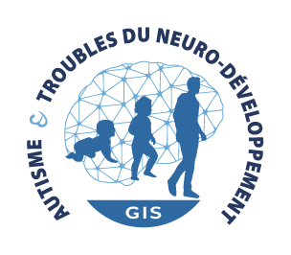
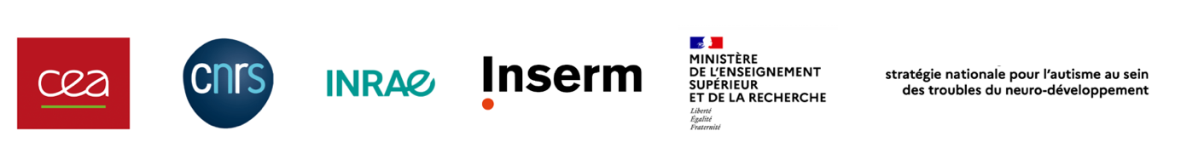
Participation form
Autism and NDDs GIS - Young researchers’ club
Invitation permanently open
Contact: paul.olivier2@inserm.fr
Supported by the French National Strategy for neurodevelopmental disorders (NDDs), the Autism and NDDs Scientific Interest Group (Groupement d’Intérêt Scientifique (GIS) Autisme et TND) aims to develop a transdisciplinary research network bringing all the relevant actors together (researchers, practitioners, associations).

The GIS’s missions are:
- Realizing a cartography of the teams involved in studying neurodevelopment and its associated disorders, of the expertise, the methodologies, the tools and resources of the research community;
- Stimulating exchanges with international actors in order to promote collaborations of transdisciplinary research;
- Accompanying and promoting the participation of research teams to national and international calls for projects;
- Developing participatory research in the field of neurodevelopmental disorders, informed by the partnership between researchers, practitioners, patients, persons with NDDs and families;
- Increasing the visibility of the communities’ actions.

The GIS (https://autisme-neurodev.org/en/) currently brings together more than 130 certified French teams (more than 750 researchers) within its scientific research networks. This network is broadly connected to the international, through scientific collaborations involving more than 400 research teams throughout the world.

Structuring such a research network must be an opportunity for every research actor including the young researchers and the young clinicians.

Therefore, the GIS offers the creation of its Young Researchers Club which will oversee actions addressed to young scientists, for instance:
- Dedicated sessions and symposium within seminars;
- Research schools;
- Research workshops;
- Social events;
- …

The goal of the Young Researchers Club is to open to young researchers an international, translational and participatory research. Besides, the Young Researchers Club network will contribute to reinforcing French research’s appeal to national and international talents. The Young Researchers Club will enable the young researchers and young clinicians to be proactive for the implementation of new scientific actions by the GIS.
The Autism and NDDs GIS sends an invitation to young researchers and young clinicians working within scientific research teams working on neurodevelopmental disorders all fields combined, to join its Young Researchers Club.

This invitation, permanently open, is addressed to young scientists meeting the following cumulative criteria:
- Scientists and/or clinicians;
- Masters, PhD students, post-docs and young researchers/clinicians with permanent positions;
- Who have not yet defended their science PhD or who have defended their science PhD less than 10 years ago;
- Working in a research team (in France or abroad) whose current and recent fields are about neurodevelopmental disorders (A-rank publications from less than 5 years ago),;
- With a desire to participate in scientific collaborations and GIS’ actions.

The research teams concerned and eager to join the Autism and NDDs GIS are invited to send back the participation form available at: https://autisme-neurodev.org/en/research-network/ or on request to Paul OLIVIER, project manager of the GIS-TND: paul.olivier2@inserm.fr

Submission procedure:
- Completed participation forms in French or English, PDF format are to be sent by email to paul.olivier2@inserm.fr
- Incomplete forms will not be considered.

INFORMATIONS REGARDING THE YOUNG RESEARCHER

Surname
Name
Date of birth
Parent organization
Name of the lab (with number) and of the home team
Name of the research team leader
Status (master, PhD, post-doc)
Date of obtention of the PhD (if applicable)
Date of appointment (if applicable)
Address
E-mail address
Phone number

Short resume (half a page max):

Publications of the young researcher (up to 5 publications from less than 5 years ago):

Motivations to join the Young Researchers Club:
Developing your network
Developing new scientific collaborations
Meeting associations of patients, concerned persons and families
Support and help in starting a project
Accessing trainings
Participating in developing participatory research
Participating in spreading scientific knowledge and good practice
Other:

