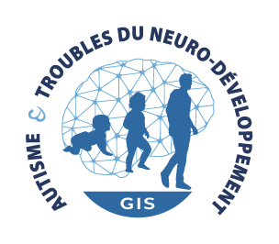
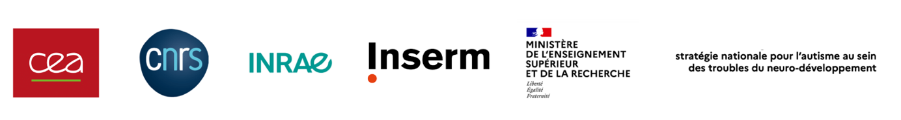

Survey of the participatory research projects within the GIS

Contact: paul.olivier2@inserm.fr
“Participatory sciences and researches are forms of scientific knowledge production involving, right beside researchers, civil society actors, individually or collectively, in an active and deliberate way”: this is the definition used in the participatory researches and sciences Charter in France.

Through their expertise, persons with NDs have a determining role in the orientations and implementations of medical research programs. For many years and in varied fields, this experiential knowledge has provided a valued perspective, source of major progress in innovation.

The Autism and NDs GIS has been for more than 4 years a decisive space for the implementation of participatory research in France, involving persons with NDDs and their families. It relies on a dedicated comity: the GRAPS ((Groupe de Réflexion des Associations de Personnes concernées pour la Science, Reflection Group of non-profit organizations of persons with NDDs for Science) which brings together the non-profit organizations of the French NDD national council. The GRAPS is at the initiative of multidisciplinary working groups (gathering researchers, practitioners and non-profit organizations) to co-construct actions for the implementation of new scientific collaborations targeting priority and cross-disciplinary issues for NDDs.

In order to increase visibility, but also to better accompany participatory research projects (in progress or in preparation) within the NND research network, the GIS is carrying out a survey of these inclusive scientific collaborations.

The first objective of this cartography will be (subject to the agreement of the scientific coordinator):
- Offering a presentation of these projects via the GIS’s communication channels (website, newsletter,…);
- Highlighting some of these projects with the future production of a video document.

The research teams concerned are invited to fill the survey form available with the following link, and to send it to Paul OLIVIER, project manager of the GIS: paul.olivier2@inserm.fr

Submission procedure:
- Completed form in French or English, PDF format to be sent to paul.olivier2@inserm.fr
- Incomplete forms will not be considered.

PART A: INFORMATION REGARDING THE SCIENTIFIC COORDINATOR OF THE PARTICIPATORY RESEARCH PROJET

Surname
Name
Date of birth
Parent organization
Name of the laboratory
Name of the research team leader
Position
Address
E-mail address
Phone number

PART B: INFORMATION REGARDING THE PARTICIPATORY RESEARCH PROJECT

Title of the participatory research project:

Acronym, if necessary:

Progress report of the project:
Study in progress
Project in preparation

Summary of the research project (half a page to a page)
Partners involved in the participatory research project (research laboratories, clinical services, non-profit organizations, specialized structures, …):
Team N° | Name of the partner team | Type of partner (research lab, non-profit organizations, …) | Name of the partner team leader | Address | Country
1
2
…
n

Participatory research fundings (please cite the sources of funding, indicating the amount of funding is not compulsory):

Agreement of the scientific coordinator of the participatory research project:

I, the undersigned, Name, Surname, member of the team Name of the team

agree that the information contained in this file may be published in the GIS communication channels (website and newsletters)

agree that the project detailed in this file may be presented as part of a future video documentary project to be produced by the GIS

Signature: Date :

